|  |  |  |  |
| --- | --- | --- | --- |
| **Test Case** | **Input** | **Expected Output** | **Actual Output / Pass or Fail** |
| **1** | HeadPhone h1 = new HeadPhone();  New Volume : 4  HeadPhone h2 = new HeadPhone(1, true, "Sony", Color.RED, "XT1");  New Volume : 4  HeadPhone h3 = new HeadPhone(2, false, "Bose", Color.BLUE, "Freerun 3");  New Volume : 4  HeadPhone h4 = new HeadPhone(3, true, "Skull Candy", Color.GREEN, "Wireless 2");  New Volume : 4 | HeadPhone 1 :  (Volume = 2  Plugged In = false Manurfacturer = null  Color = null HeadPhoneModel = null)  No volume change  HeadPhone 2 :  (Volume = 1  Plugged In = true Manurfacturer = Sony Color = Red HeadPhoneModel = XT1)  No volume change  HeadPhone 3 : (Volume = 2 Plugged In = false Manurfacturer = Bose Color = Blue HeadPhoneModel = Freerun 3)  No volume change  HeadPhone 4 :  (Volume = 3  Plugged In = true Manurfacturer = Skull Candy  Color = Green HeadPhoneModel = Wireless 2)  No volume change | HeadPhone 1 :  (Volume = 2  Plugged In = false Manurfacturer = null  Color = null HeadPhoneModel = null)  No volume change  HeadPhone 2 :  (Volume = 1  Plugged In = true Manurfacturer = Sony Color = Red HeadPhoneModel = XT1)  No volume change  HeadPhone 3 :  (Volume = 2  Plugged In = false Manurfacturer = Bose Color = Blue HeadPhoneModel = Freerun 3)  No volume change  HeadPhone 4 :  (Volume = 3  Plugged In = true Manurfacturer = Skull Candy  Color = Green HeadPhoneModel = Wireless 2)  No volume change  PASS |

**Reasoning and Expected Output:**

* Initial tests of program, using expected inputs
* Should output all values in a string, with no new volume value printed.

**Actual Output Test Case 1 Screen shot:**

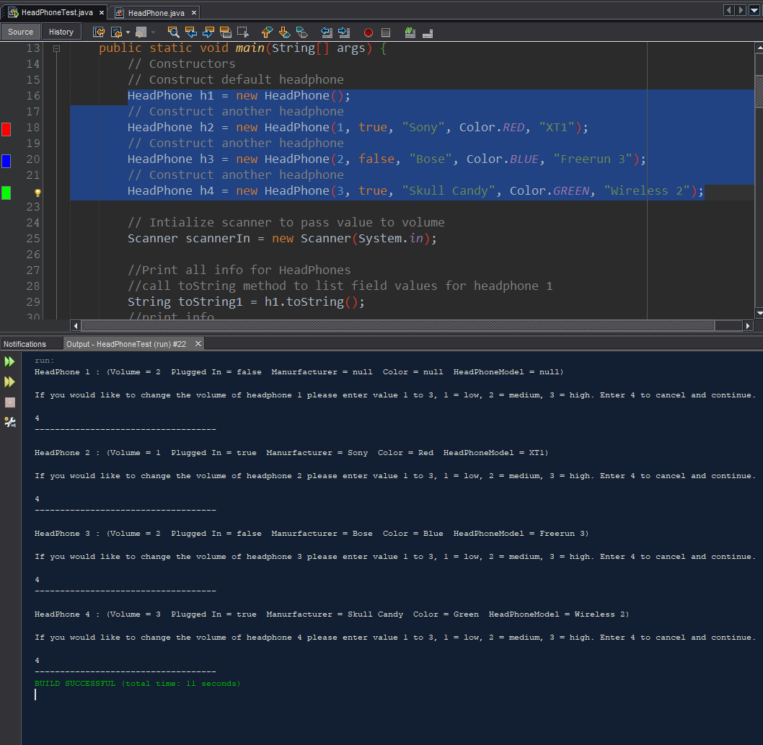

|  |  |  |  |
| --- | --- | --- | --- |
| **Test Case** | **Input** | **Expected Output** | **Actual Output / Pass or Fail** |
| **2** | HeadPhone h1 = new HeadPhone();  New Volume : 1  HeadPhone h2 = new HeadPhone(3, false, "Duke Nukem", Color.YELLOW, "Wave After Wave");  New Volume : 2  HeadPhone h3 = new HeadPhone(2, false, "Serious Sam", Color.BLACK, "Getting Serious");  New Volume : 3  HeadPhone h4 = new HeadPhone(1, false, " Doom ", Color.RED, "Monster Destroyer");  New Volume : 3 | HeadPhone 1 :  (Volume = 2  Plugged In = false Manurfacturer = null  Color = null HeadPhoneModel = null)  New Volume = 1  HeadPhone 2 :  (Volume = 3  Plugged In = false Manurfacturer = Duke Nukem  Color = Yellow HeadPhoneModel = Wave After Wave)  New Volume = 2  HeadPhone 3 : (Volume = 2 Plugged In = false Manurfacturer = Serious Sam  Color = Black HeadPhoneModel = Getting Serious)  New Volume = 3  HeadPhone 4 :  (Volume = 1  Plugged In = false Manurfacturer = Doom  Color = Red HeadPhoneModel = Monster Destroyer)  New Volume = 3 | HeadPhone 1 :  (Volume = 2  Plugged In = false Manurfacturer = null  Color = null HeadPhoneModel = null)  New Volume = 1  HeadPhone 2 :  (Volume = 3  Plugged In = false Manurfacturer = Duke Nukem  Color = Yellow HeadPhoneModel = Wave After Wave)  New Volume = 2  HeadPhone 3 : (Volume = 2 Plugged In = false Manurfacturer = Serious Sam  Color = Black HeadPhoneModel = Getting Serious)  New Volume = 3  HeadPhone 4 :  (Volume = 1  Plugged In = false Manurfacturer = Doom  Color = Red HeadPhoneModel = Monster Destroyer)  New Volume = 3  PASS |

**Reasoning and Expected Output:**

* Change of colors and other inputs to ensure it works, also will change volume of each headphone.
* Should output all values in a string, with new volume.

**Actual Output Test Case 2 Screen Shot:**

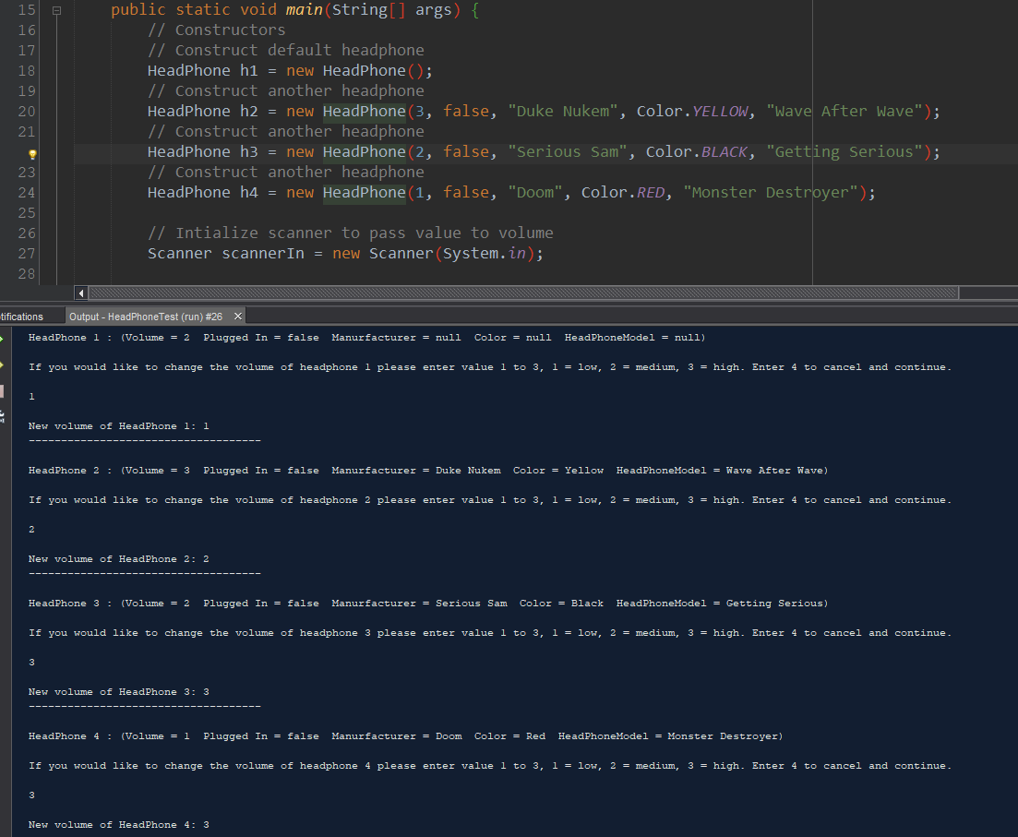

|  |  |  |  |
| --- | --- | --- | --- |
| **Test Case** | **Input** | **Expected Output** | **Actual Output / Pass or Fail** |
| **3** | HeadPhone h1 = new HeadPhone();  New Volume : 0  HeadPhone h2 = new HeadPhone(3, false, "Duke Nukem", Color.YELLOW, "Wave After Wave");  New Volume: -2  HeadPhone h3 = new HeadPhone(-2, false, "Serius Sam", Color.BLACK, "Getting Serious");  New Volume: 1  HeadPhone h4 = new HeadPhone(0, false, "Doom", Color.PINK, "Monster Destroyer");  New Volume: 3 | HeadPhone 1 :  (Volume = 2  Plugged In = false Manurfacturer = null  Color = null HeadPhoneModel = null)  No New Volume  HeadPhone 2 :  (Volume = 3  Plugged In = false Manurfacturer = Duke Nukem  Color = Yellow HeadPhoneModel = Wave After Wave)  No New Volume  HeadPhone 3 : (Volume = 2 Plugged In = false Manurfacturer = Serious Sam  Color = Black HeadPhoneModel = Getting Serious)  New Volume = 1  HeadPhone 4 :  (Volume = 0  Plugged In = false Manurfacturer = Doom  Color = Red HeadPhoneModel = Monster Destroyer)  New Volume = 3 | HeadPhone 1 :  (Volume = 2  Plugged In = false Manurfacturer = null  Color = null HeadPhoneModel = null)  No New Volume  HeadPhone 2 :  (Volume = 3  Plugged In = false Manurfacturer = Duke Nukem  Color = Yellow HeadPhoneModel = Wave After Wave)  No New Volume  HeadPhone 3 : (Volume =-2 Plugged In = false Manurfacturer = Serious Sam  Color = Black HeadPhoneModel = Getting Serious)  New Volume = 1  HeadPhone 4 :  (Volume = 0  Plugged In = false Manurfacturer = Doom  Color = Red HeadPhoneModel = Monster Destroyer)  New Volume = 3 |

**Reasoning and Expected Output:**

* Testing unexpected values to see if it fails to run. I found it will not compile with missing values due to their being no partial constructor. Will also not compile if I choose color that I did not define a color name for.
* Should output all values in a string, with new volume. If originally constructed object had an invalid volume, user should be able to change it to valid and if user inputs invalid volume program will not accept it. Invalid inputs also act as sentinel value allowing skipping of volume change.
* Also added a few lines of code at end to print current values of volumes to ensure value was being passed to change volume method.

**Actual Output: Pass**

